Standard Operating Procedure
SOLDERING
This is an SOP template and is not complete until: 1) lab specific information is entered into the box below 2) lab specific protocol is added to the each section and
3) SOP has been signed and dated by the PI and relevant lab personnel.
Maintain this document in your Lab-Specific Chemical Hygiene Plan.

Lab-Specific Information
Chemical(s) covered by this SOP: | Click here to enter text.
Building/Room(s) covered by this SOP: | Click here to enter text.
Department: | Click here to enter a date.
Principal Investigator Name: | Click here to enter a date.
Principal Investigator Approval Signature: | Click here to enter text.

University of Washington
#1 Process | This SOP template addresses the use of electric soldering irons and the hazards of leaded and non-leaded soldering of electrical components in the following procedure(s):  [Enter laboratory-specific process/procedure here.]
#2 Chemicals and Hazards | 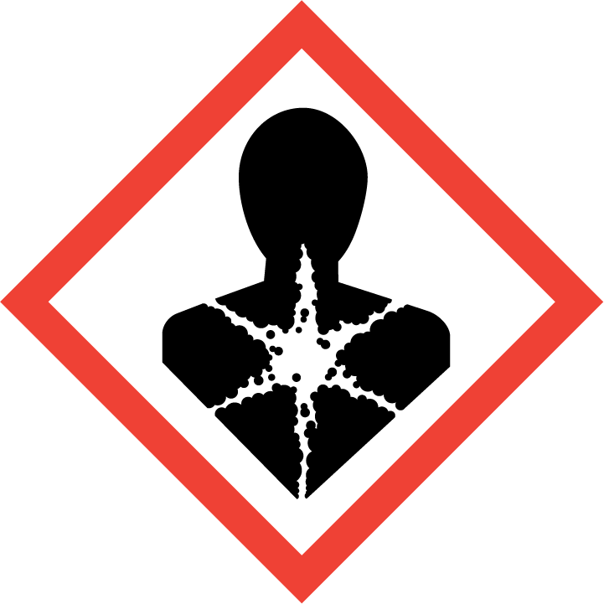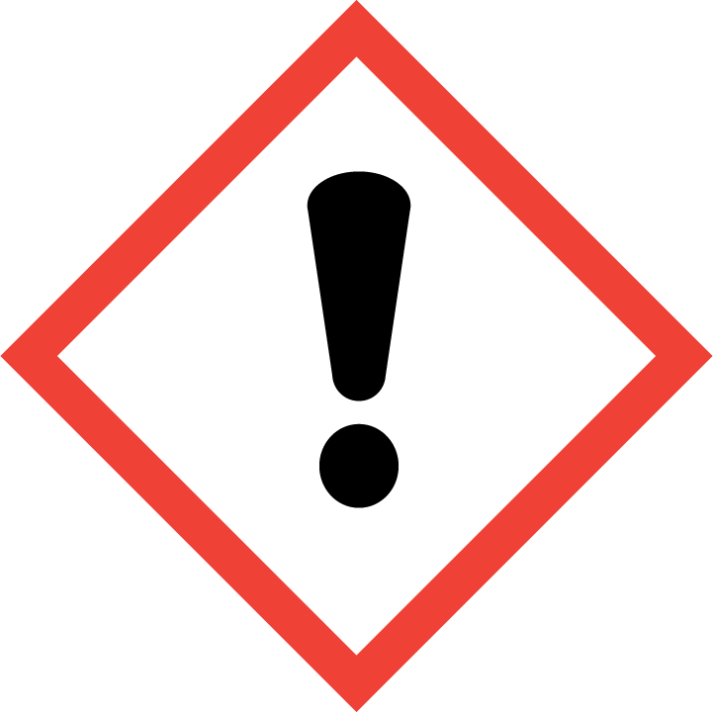  Leaded soldering:  - Solder must be entered into MyChem inventory.  - Locate and review the manufacturer’s Safety Data Sheet for the specific solder material used by your lab and add pertinent information to this SOP: [Enter laboratory-specific information here.]  - The World Health Organization’s International Agency for Research on Cancer classifies lead as a Group 2A Carcinogen, meaning it is Probably Carcinogenic to Humans.  - The primary route of exposure to lead from soldering is ingestion of lead due to surface contamination.  - Skin contact with lead is harmless, but lead dust on your hands can result in ingestion if hands are not thoroughly washed before eating, smoking, etc. DO NOT eat, drink, or store food/beverage containers in soldering areas. Hand-to-mouth gestures also increase potential exposure.  - Keep work surfaces as clean as possible to avoid ingestion.  - Refer to the UW EH&S Lead Safety Program Manual: https://www.ehs.washington.edu/system/files/resources/lead-safety-program-manual.pdf and the Lead Safety Focus Sheet: https://www.ehs.washington.edu/system/files/resources/lead-safety-shops-labs.pdf for additional information.  - Completion of Lead Awareness (online) training prior to working with leaded solder is strongly recommended: https://www.ehs.washington.edu/training/lead-awareness-%E2%80%93-online  - Short-term over-exposure to lead can cause abdominal pain, digestive problems, fatigue, headaches, irritability, loss of appetite, memory loss, pain, or tingling in hands or feet.  - Chronic exposure to lead can lead to reproductive problems, digestive problems, memory and concentration problems, muscle and joint pain, depression, irritability, and nausea.  Lead-free soldering:  - Solder must be entered into MyChem inventory.  - Locate and review the manufacturer’s Safety Data Sheet for the specific solder material used by your lab and add pertinent information to this SOP: [Enter laboratory-specific information here.]  - Lead-free solder requires higher soldering iron temperatures, as well as higher acidity fluxes, which are more likely to volatilize and become inhalation hazards.  Solder flux:  - Solder flux must be entered into MyChem inventory.  - Locate and review the manufacturer’s Safety Data Sheet for the specific flux material used by your lab and add pertinent information to this SOP: [Enter laboratory-specific information here.]  - Flux containing rosin (also called colophony) generates visible fumes. Rosin’s boiling point range starts as low as 100C, and generates solvent vapor when heated to soldering temperature.  - Rosin exposure can cause asthma, or make existing asthmatic conditions worse. The fumes can also cause eye and upper respiratory tract irritation.  - Lead-free solder requires higher soldering iron temperatures, as well as higher acidity fluxes, which are more likely to volatilize and become inhalation hazards.  Soldering Iron:  - Locate and review the manufacturer’s instruction manual for the specific soldering iron used by your lab and add pertinent information to this SOP: [Enter laboratory-specific information here.]  - The temperature of the heated tip can reach 400C, and will cause severe burns. The tip can also cause serious damage to loos clothing, hair, electrical wires and surrounding workspace.  - Touching the hot iron to power cords can melt through insulation and cause electrical shock.  - [Enter laboratory-specific information here.]
#3 Personal Protective Equipment (PPE) | - Safety glasses/goggles [Enter laboratory-specific type here.]  - Gloves [Enter laboratory-specific glove type here.]  - Lab coat/apron/coveralls. [Enter laboratory-specific type here.]
#4 Environmental/  Ventilation Controls | When heated, the solder and flux are capable of producing large amounts of smoke. Because soldering fumes typically rise vertically in the air, they can easily enter a person’s breathing zone if adequate ventilation is not used. When inhaled, this smoke can prompt breathing problems. Over time, these fumes can cause serious damage to one’s health.  A fume hood or local exhaust ventilation system (e.g., snorkel exhaust hood, benchtop fume extractor) designed to remove lead particulate, fume or vapors should be available for all soldering activities.  Ensure that work surface is fire-resistant.  [Enter laboratory-specific information here.]
#5 Special Handling Procedures & Storage Requirements | Before Starting work:  Identify location of nearest eye-wash station and first-aid kit prior to start of work.  Locate nearest hand- and face-washing facilities prior to start of work.  Keep the work area free from dust and debris using a HEPA vacuum and/or wet cleaning methods before and immediately after soldering activities to reduce airborne releases.  Do not remove dust from soldering area by blowing or shaking.  Check the condition of the soldering tip and replace if damaged.  Ensure the tip is ‘tinned’ and free from waste build-up. Wipe tip on damp sponge to clean once iron has warmed up.  Ensure that the cord does not come into contact with the hot tip and does not create a slip/trip hazard.  Leave the soldering iron in the stand when warming up and when not in active use. Always allow the soldering iron to reach the desired temperature before starting work.  During work:  Keep the cleaning sponge damp during soldering activities.  Avoid ingestion: NO FOOD OR DRINK in soldering areas.  Avoid inhalation: Keep head to side of work, not above.  Avoid contact: Soldering iron and newly soldered joints are extremely hot. Keep fingers clear.  Avoid prolonged use: Tip element may overheat, causing it to fail and/or oxidize.  Leave soldering iron in the stand when not in active use. DO NOT leave the soldering iron unattended when turned on or still hot.  After completion of work:  Physical contact with lead dust from lead soldering operations is the most common form of potential exposure to lead. It is important to ensure lead dust does not remain on your hands or on your clothes.  Wet-wipe all solder-contaminated surfaces with soapy water and paper towels, or a lead removal product. Dispose of clean-up materials as hazardous waste.  DO NOT remove dust from soldering area by blowing or shaking.  Wash hands and face with soap and water immediately after soldering activities are completed.  [Enter laboratory-specific information here.]
#6 Spill and Accident Procedures | FIRE: Follow your department’s emergency procedures, which may include completing Fire Extinguisher Training prior to performing soldering activities. Always know the location of the nearest fire extinguisher. In case of a small, contained fire, use the fire extinguisher only if you have been trained and it is safe to do so. If there is an imminent threat of a significant fire, pull the nearest fire alarm station to evacuate the building and dial 911.  SKIN CONTACT: If there is a burn, immediately cool the affected area under cold water for 15 minutes. Do not apply any creams or ointments. Cover with a bandage.  EYE CONTACT: Flush eyes for 10-15 minutes while holding eyelids open.  INHALATION: If irritationg fumes are inhaled, immediately move to get fresh air.  INGESTION: do not induce vomiting.  EXPOSURE INCIDENTS: In cases where an employee develops signs or symptoms of lead exposure or suspects that lead- containing material may have been disturbed:  •Work must be stopped immediately.  •The employee must notify his/her supervisor immediately.  •Access to the work area must be restricted to prevent others from unknowingly entering a contaminated area.  •Contact UW Employee Health at emphlth@uw.edu or 206.685.1026 to consult with an occupational medical professional regarding lead exposures.  SPILL INCIDENTS: If employee is qualified and comfortable, small spills and releases may be cleaned up with proper PPE using soapy water and paper towels, or a lead removal product. Bag or contain the spilled material and debris, and cleanup materials. Double bag all waste in plastic bags labeled with a hazardous waste label for EH&S pickup. If a significant spill or release occurs, stop work. Properly protected and trained personnel must clean up spills immediately. Do not attempt to clean up any spill if not trained, wearing appropriate personal protective equipment, or comfortable. For large spills, evacuate the area and call 9-1-1* on any campus phone for help.  For questions on spill cleanup, contact EH&S Spill Advice consultants at 206.543.0467* On the UW Seattle campus call 9-1-1 on a campus phone; at UW medical centers and other locations, follow internal emergency procedures.  Report all accidents and incidents to the Online Accident Reporting System within 24 hours (8 hours if hospitalization).
#7 Waste Disposal | Dispose of waste liquids and solids (wet wipes and other debris) as hazardous chemical waste.  Label with Hazardous Waste Label, accumulate according to requirements, and send in Chemical Collection Request or Routine Pickup request, both available online at http://www.ehs.washington.edu/chemical/hazardous-chemical-waste-disposal.
#8 Special Precautions for Animal Use  (if applicable) | [Enter laboratory-specific information here if applicable.]
Particularly hazardous  substance involved? |  | YES: | Blocks #9 to #11 are Mandatory for Lead Solder. Check SDS to determine if non-leaded solder and/or flux contains particularly hazardous substance(s).
 |  | NO: | Blocks #9 to #11 are Optional.
#9 Approval Required | The PI must train staff on procedures and observe the first procedure of a new employee prior to allowing independent work.  [Enter laboratory-specific information here.]
#10 Decontamination | Wet-wipe all solder-contaminated surfaces with soapy water and paper towels, or a lead removal product. Dispose of clean-up materials as hazardous waste.  DO NOT remove dust from soldering area by blowing or shaking.  Wash hands and face with soap and water immediately after soldering activities are completed.  [Enter laboratory-specific information here.]
#11 Designated Area | [Enter laboratory-specific information here.]
Author Name: [Enter name here.] Title: [Enter PI/CHO/Lab Manager here.]
Signature: [Sign here.] Date: [Enter date here.]

NOTE: Any deviation from this SOP requires prior approval from the Principal Investigator.
Documentation of Training (signature of all users is required)
Prior to conducting any soldering activities, the Principal Investigator must ensure that all laboratory personnel receive training on the content of this SOP.
I have read and understand the content of this SOP:
Name | Signature | Date
Click here to enter text. |  | Click here to enter a date.
Click here to enter text. |  | Click here to enter a date.
Click here to enter text. |  | Click here to enter a date.
Click here to enter text. |  | Click here to enter a date.
Click here to enter text. |  | Click here to enter a date.
Click here to enter text. |  | Click here to enter a date.
Click here to enter text. |  | Click here to enter a date.

