INSTRUCTIONS: This is an SOP template; it is complete when
1) All form fields have been completed to reflect chemical/lab-specific information, including adding relevant procedure information, or deleted inapplicable information; and
2) SOP has been signed and dated by the PI and relevant lab personnel.
Use safety data sheets (SDSs) as a resource for chemical-specific information. Text highlighted in gray indicates where information should be added or edited. Delete all instructions in red text and “Draft” watermark after the SOP is approved by PI.
Standard Operating Procedure
Aqua Regia
Print a copy and insert into your Lab-Specific Chemical Hygiene Plan.
Section 1 – Lab-Specific Information
Building/Room(s) covered by this SOP:
Unit or department:
Principal Investigator Name:
Principal Investigator Signature/Date:
This SOP was created by (if not PI):
Name/Title/Date/Signature:

Section 2 – Hazards
Aqua Regia is a highly corrosive and strongly oxidizing solution that is best known for its ability to dissolve gold and platinum. It is commonly used to remove a wide variety of inorganic or trace organic contaminants from laboratory glassware or noble metal substrates, as in microfabrications and microelectronics labs.
Aqua Regia should be used only when it is deemed necessary. Aqua Regia will self-heat when freshly mixed, which may lead to severe chemical or thermal burns on contact, and can undergo violent exothermic reactions with organic compounds and other flammable materials. Aqua Regia must be handled with extreme caution, and safe use requires the consideration of several different types of hazards. Consult with PI or supervisor before using Aqua Regia for the first time.
The most common Aqua Regia is a 1:3 (v/v) mixture of concentrated nitric acid (HNO_{3,} ≤70%) and hydrochloric acid (HCl, ≤37%). Aqua Regia will decompose after mixing. The expected gaseous products include nitrosyl chloride (NOCl), chlorine (Cl₂), nitric oxide (NO), and nitrogen dioxide (NO₂). These gases are acutely toxic inhalation hazards. Gas evolution may also lead to a build-up of pressure that could cause a sealed container to fail catastrophically.
Direct exposure will cause itching, redness, burns, inflammation, swelling, and/or serious tissue damage and immediate pain upon contact. Aqua Regia is toxic if inhaled and will irritate the respiratory tract. The vapors are strongly corrosive and are extremely destructive to the tissue of the mucous membranes and upper respiratory tract. Harmful if swallowed; causes severe and rapid burns of the mouth, gullet and gastrointestinal tract, causing burning, chocking, nausea, vomiting and severe pain. Do NOT induce vomiting.
The severity of damage depends on the dose, duration of exposure, and the body parts contacted.
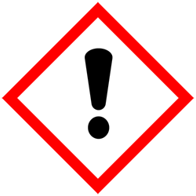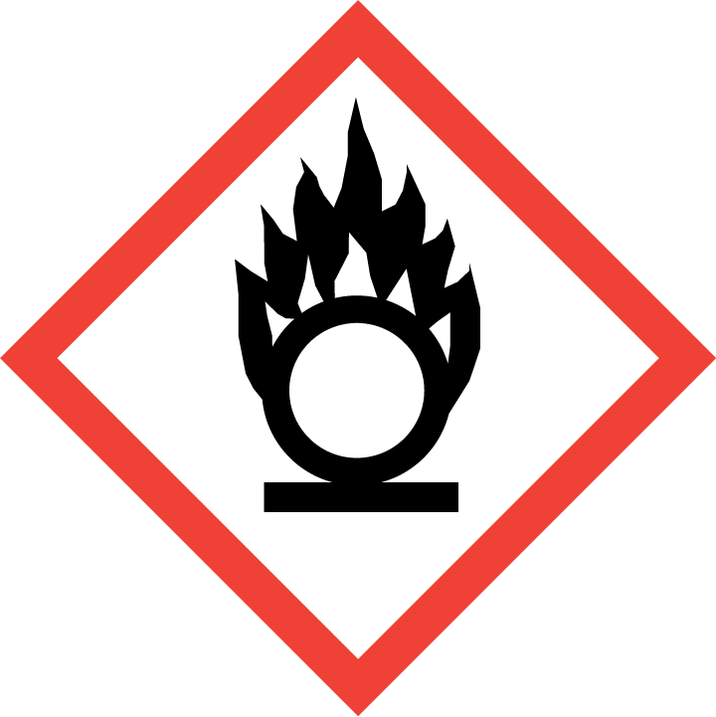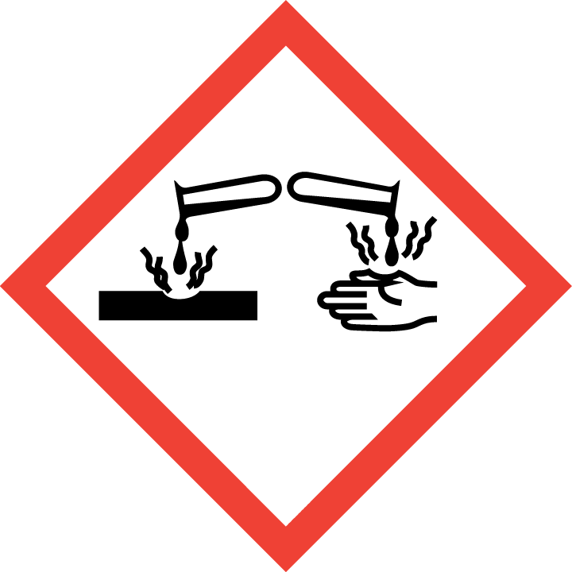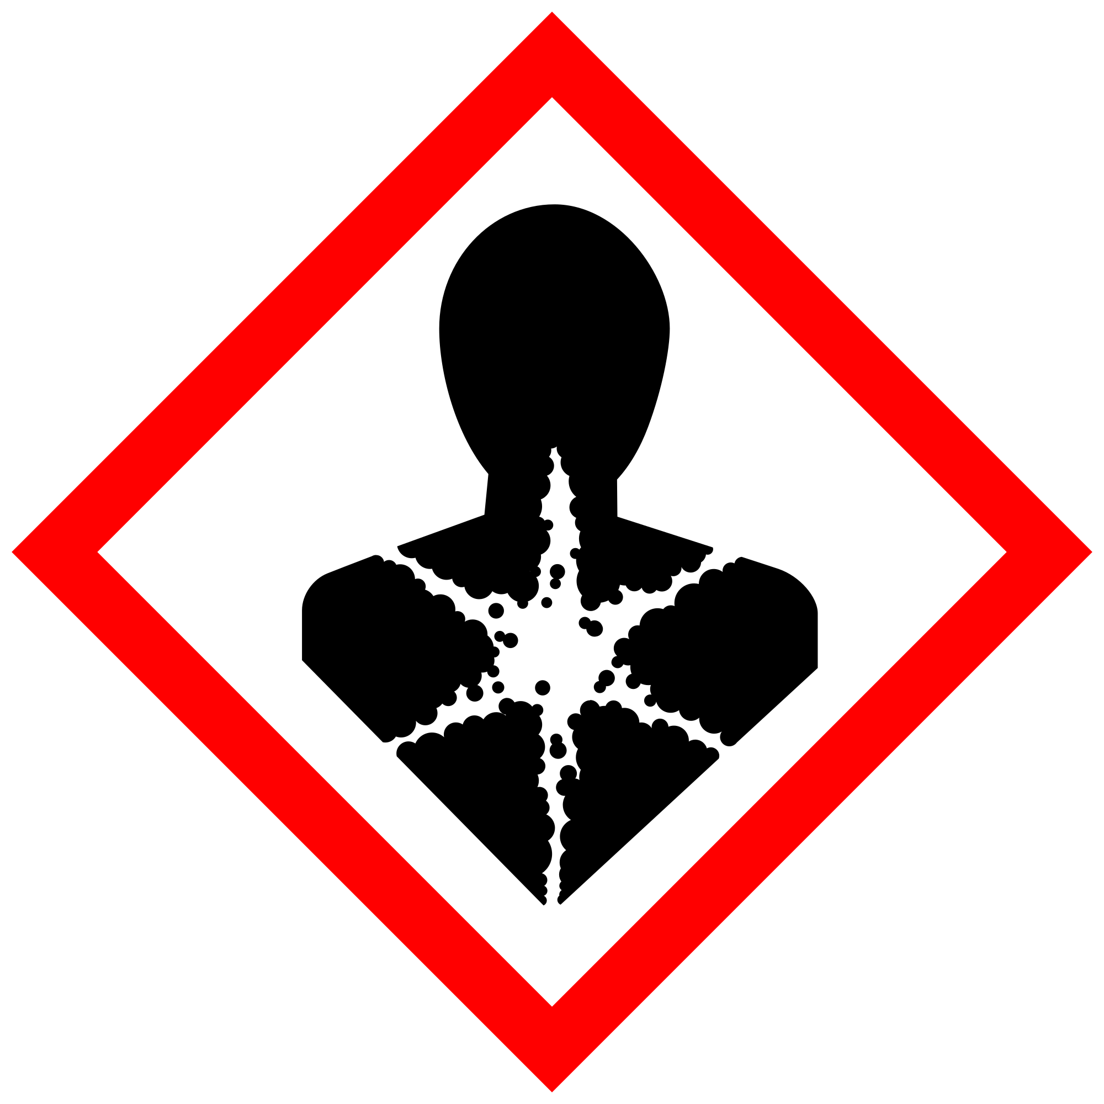
Section 3 – Engineering and Personal Protective Equipment (PPE)
REQUIRED - Insert descriptions and locations of lab-specific ventilation controls and equipment utilized to reduce the risk of Acid Piranha chemical exposures.
Engineering Controls: All work with Aqua Regia must be conducted in a properly functioning chemical fume hood whenever possible. The chemical fume hood must be approved for use by EH&S.Keep the sash as low as possible to prevent the release of toxic gases. The sash should be positioned between the researcher and the Aqua Regia solution whenever practical to minimize the chance of injuries from splashing.
Using corrosives and strong oxidizers at elevated temperatures may require facility-specific engineering/ventilation controls. Contact UW EH&S at labcheck@uw.edu for guidance.
Details:

Hygiene Measures: Avoid contact with skin, eyes, and clothing. Wash hands after removing PPE before breaks and immediately after handling the chemical. If Aqua Regia comes into contact with any PPE, the PPE shall be immediately removed and discarded properly. Any potentially exposed body parts should be washed immediately.
REQUIRED - Insert the lab-specific gloves or glove combination that are required for use with Aqua Regia. When possible, include the exact manufacturer and model information.
Hand Protection: Hand protection is required for the activities described in this SOP. A single layer of disposable Nitrile gloves will NOT provide sufficient protection and are NOT recommended for concentrated (>70%) nitric acid, which is a component of Aqua Regia, according to the Ansell Chemical Resistance Guide.
Two-sets of chemical-resistant gloves should be worn (“double-gloving”). A heavy-duty (≥10 mil) chemically resistant, glove, such as butyl rubber, Viton, or equivalent, is recommended when handling significant volumes of Aqua Regia and its components. NOTE: Consult with your preferred glove manufacturer to ensure that the gloves you plan to use are compatible with the specific chemical being used.
Gloves must be inspected prior to use, including a check for pinholes.
Use proper glove removal technique (without touching glove's outer surface) to avoid skin contact with this product. Dispose of contaminated gloves after use in accordance with applicable laws and good laboratory practices. Wash and dry hands immediately after glove removal.

Details:

Eye Protection: ANSI Z87.1-compliant eye protection is required for all work with Aqua Regia. At a minimum, safety glasses are necessary. Splash goggles may be substituted for safety glasses, and are required for processes where splashes are foreseeable or when generating aerosols. A full face shield should be worn when splashing is foreseeable. Ordinary prescription glasses will NOT provide adequate protection.
Skin and Body Protection: Chemically compatible laboratory coats that fully extend to the wrist must be worn and be appropriately sized for the individual and buttoned to their full length. If a risk of fire exists, a flame-resistant laboratory coat that is NFPA 2112-compliant should be worn. Some FR fabrics (e.g., Nomex®, Rhovyl®, Kevlar®, etc.) are highly permeable and do not provide good chemical/acid resistance. Personnel must also wear full-length pants, or equivalent, and close-toed shoes. The area of skin between the shoe and ankle must not be exposed.
Disposable sleeves and an acid-resistant apron are required where splashes or skin contact is foreseeable. If handling large (> 500 mL) quantities, an acid-resistant apron shall be worn.
Details:

Respiratory Protection: Respirators should be used as a last line of defense (i.e., after engineering and administrative controls have been exhausted), when Permissible Exposure Limit (PEL) has been exceeded, when there is a possibility that PEL will be exceeded, or as PPE in the event of a chemical spill clean-up process. If this activity is necessary, contact EH&S at 206.543.7388 so a respiratory protection analysis can be performed.
Section 4 – Special Handling and Storage Requirements
- Do not work alone with Aqua Regia;
- A warning sign, visible by any user working in the area, must be posted at all times to indicate the solution contains an Aqua Regia mixture;
- A container of suitable spill control material (e.g., clean dry sand, vermiculite, etc.) and neutralization agent (e.g., sodium bicarbonate) must be available for any Aqua Regia spills;
- Aqua Regia must only be used in a properly functioning fume hood and in a room with a properly functioning eyewash. A safety shower must be available within 10 seconds of travel;
- Do not remove Aqua Regia (in use, spent, excess, or waste) from the fume hood where it was made;
- No other work should be carried out in the fume hood whenever active Aqua Regia solution is present;
- Unless absolutely necessary, organic compounds and other flammable materials should be removed from the fume hood before working with Aqua Regia;
- Whenever preparing/handling Aqua Regia, glass containers (preferably borosilicate) in good condition should be used. Secondary containment (e.g., a large polypropylene or polyethylene tray) shall be used for all Aqua Regia work;
- Containers should be labeled appropriately. Label should indicate the name of the chemical(s) in the container. Avoid using chemical abbreviations and formulae;
- Make the smallest practical quantities needed for daily use in the experiment being performed;
- Never place Aqua Regia in a sealed container as catastrophic failure can occur due to gas generation and consequential over pressurization. All waste bottles shall have a vented cap;
- Always add nitric acid (HNO3) to hydrochloric acid (HCl), never vice versa. Perform the addition slowly to prevent uncontrolled boiling and potential splashing;
- Do not store Aqua Regia solution. Prepare a fresh solution for each use and only as much as needed for the specific use; and
- Avoid contact with skin and eyes, and do not inhale.
REQUIRED - Insert descriptions of any additional administrative controls (e.g., restrictions on procedure/quantity/work equipment/work locations/unattended operations/etc.), including controls that may be chemical-specific (e.g., peroxide formers).

Section 5 – Spill and Accident Procedures
Spills must be cleaned up immediately by properly protected and trained personnel. All other persons should leave the area. Spill response procedures must be developed based on the chemical and potential spill or release conditions and using the appropriate spill kit. Do not attempt to clean up any spill if not trained or comfortable.
Exposures: If a person is injured, exposed, or suspected of being exposed to Aqua Regia, follow procedures listed here. Bring this SOP and Safety Data Sheets (SDSs) for nitric acid and hydrochloric acid with you to show medical personnel.
Skin exposure: remove contaminated clothing and shoes, rinse for 15 minutes in the safety shower and wash skin with soap. Send someone to call 911 as soon as possible.
Eye exposure: call 911 as soon as possible, remove contact lenses, and flush eyes for 15 minutes in the eyewash. Continue rinsing eyes during transport to hospital.
Inhalation: exposed persons should be moved to fresh air immediately. Call 911.
Ingestion: do NOT induce vomiting. If conscious, wash mouth out with water and call 911.
Immediately evacuate area if fumes present a serious health risk or a large spill (> 0500 mL) occurs; ensure others are aware of the spill. Avoid breathing fumes. During normal business hours (Monday – Friday, 8 AM – 5 PM), call EH&S at 206.543.0467 for further assistance. If it is after hours, call 911 for further assistance. If possible, confine the spill to a small area using a spill kit or absorbent material. Keep others from entering contaminated area (e.g., use caution tape, barriers, etc.).
Spill procedures for small spills (<500 mL) within the fume hood:
Trained personnel must clean up immediately using appropriate personal protective equipment listed above and clean-up material for chemical spilled. All other persons should leave the area. Prevent the spread of the Aqua Regia spill by encircling it with a layer of suitable inert sorbent material. Slowly and carefully neutralize the remaining Aqua Regia and sorbent material with a dilute solution of sodium carbonate and inert sorbent material. Do not absorb the spill without neutralizing first. Collect spill cleanup materials, double bag and securely fasten spill materials. Label with a hazardous waste label that reads “Aqua Regia spill debris, contains nitric acid and hydrochloric acid.” Complete either an Online Chemical Waste Collection Request or a Chemical Collection Request Form found on the EH&S website. Email the form to chmwaste@uw.edu
Clean the spill area thoroughly with detergent solution followed by clean water. If spill is extensive within the containment, clean all interior surfaces after completion of the spill cleanup.
Spill procedures for large spills (>500 mL) or any amount outside of the fume hood:
Given the acute toxicity of gases formed by Aqua Regia, no spills outside of a chemical fume hood should be cleaned up by laboratory personnel.
Immediately evacuate area; ensure others are aware of the spill. Avoid breathing fumes. Attend to injured or exposed persons using emergency shower or eyewash following procedures listed above under Exposures. If possible, confine the spill to a small area using a spill kit or absorbent material. Keep others from entering contaminated area (e.g., use caution tape, barriers, etc.).
As soon as possible, report the spill in a safe area by notifying EH&S at 206.543.0467 for further assistance during normal business hours (Monday – Friday, 8 AM – 5 PM). If it is after hours, call 911 for further assistance. Tell them that a spill has occurred, and you need help managing the spill. EH&S can arrange for a spill cleanup contractor. Notify Supervisor.
Be prepared to provide the following information:
- Name and phone number of knowledgeable person that can be contacted
- Name of chemical spilled, concentration and amount spilled, liquid or solid type spill
- Number of injured, if any
- Location of spill
Report all spills via the EH&S Online Accident Reporting System (OARS) within 24 hours (8 hours if serious injury or hospitalization).
REQUIRED - Insert descriptions of any specialized spill clean up procedures for materials used in this SOP, including the procedures for corrosive spill cleanup. Additional details of lab-specific spill cleanup should be provided if applicable.
INSERT IF APPLICABLE - Descriptions of any specialized emergency procedures for locations outside of a UW campus or facility.
Section 6 – Waste Disposal Procedures
Double bag all spill waste in plastic bags labeled with a hazardous waste label that reads "Aqua Regia spill debris.” Complete either an Online Chemical Waste Collection Request or a Chemical Collection Request Form on the EH&S website. Email the form to chmwaste@uw.edu. Store Aqua Regia spill waste as hazardous waste in a designated area within a fume hood. Decontaminate equipment and bench tops using soap and water.
DO NOT COMBINE ANY OTHER WASTE SOLUTION WITH AQUA REGIA. Mixing Aqua Regia with organic compounds may cause an explosion. Aqua Regia quickly loses its effectiveness due to oxidation of its reactive components. The spent solution should still be considered an oxidizer, and should be stored in a dedicated and properly labeled glass waste bottle with a pressure-vented cap.
All used and excess Aqua Regia should be allowed to cool and cease gas generation before being collected and stored as hazardous waste using the procedure described below.
Avoid having excess unused solution. If any excess unused Aqua Regia remains at the end of the work day, wait for the solution to fully decompose and cool to ambient temperature. Once the used and excess solutions have returned to a yellow color and are no longer evolving any gases, carefully add to the waste container using the procedure described below.
Be sure the waste container is a suitable compatible material (e.g., clear glass or a recycled nitric or hydrochloric acid bottle) and has a vented cap or other mechanism to prevent the build-up of pressure. Initially only add a small amount of the solution to the waste container to ensure there are no residual materials in the container that may cause an adverse reaction, realizing the adverse reaction may take minutes to hours to manifest. If no reaction is observed, continue to pour slowly. At least 25% of the waste container volume should be left empty. The container shall be labeled as “Aqua Regia Solution: Corrosive & Oxidizer” in addition to listing all components (nitric acid, hydrochloric acid, etc.) on the appropriate hazardous waste label. A vented cap must be used on the waste container and the container must be stored in a certified fume hood. DO NOT STORE AQUA REGIA LONG TERM. Contact EH&S for pickup of Aqua Regia waste in a timely manner. Note: vented caps will not be returned after collection.
Upon completion of work with Aqua Regia and/or decontamination of equipment and work area, remove gloves and/or PPE to wash hands and arms with soap and water. Additionally, upon leaving a designated Aqua Regia work area remove all PPE worn and wash hands, forearms, face and neck as needed. Contaminated clothing and PPE should not be removed from the laboratory, and should undergo proper decontamination or disposal.
REQUIRED - Insert descriptions of laboratory-specific information on the waste streams generated, storage location, and any special handling/storage requirements.
REQUIRED - Insert descriptions of decontamination procedures for equipment, glassware, and controlled areas (e.g., glove boxes, restricted access hoods, perchloric/hot acid fume hoods, or designated portions of the laboratory).

Section 7 – Protocol (Add lab specific Protocol/Procedure here)
Aqua Regia must be prepared, used, and stored in a certified fume hood. Prepare the minimum volume necessary for daily use. Aqua Regia is typically prepared by slowly adding one volume of concentrated HNO₃ to three equivalent volumes of concentrated HCl in a suitable glass vessel. Upon mixing, the colorless solution quickly becomes hot and turns yellow in color, which successively darkens to an orange or red fuming solution over several minutes. The yellow-brown fumes contain NOCl, Cl₂, NO, and NO₂, which must not be inhaled. The Aqua Regia solution is now ready for use, which must only occur in open or vented glass vessels. Once the solution returns to a yellow color and gas evolution ceases, Aqua Regia has lost its potency (though it remains strongly acidic and oxidizing). See Section 6 for proper handling and storage of use and excess Aqua Regia.
REQUIRED - Insert or attach detailed laboratory-specific procedures for the process, hazardous chemical(s), or hazard class. You may also include any relevant supporting resources such as journal citations, etc. that are applicable.
Click here to enter text.
NOTE: Any deviation from this SOP requires approval from Principal Investigator.

Section 8 – Documentation of Training (signature of all users is recommended)
- Prior to using Aqua Regia, laboratory personnel must be trained on the hazards described in this SOP, how to protect themselves from the hazards, and emergency procedures.
- Ready access to this SOP and to a Safety Data Sheet for each hazardous material described in the SOP (Nitric Acid, Hydrochloric Acid, other substances used in the process) must be made available.
- The Principal Investigator (PI), or the Responsible Party, must ensure that their laboratory personnel have completed lab-specific training and completed EH&S’s Managing Lab Chemicals training (and refresher training where applicable).
- Training must be repeated following any revision to the content of this SOP. Training must be documented. This training sheet is provided as one option; other forms of training documentation (including electronic) are acceptable but records must be accessible and immediately available upon request.
I have read and understand the content of this SOP:
Name | Signature | Date

