[Insert Chemical Name]
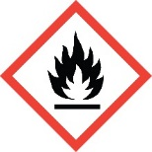 | 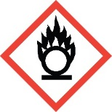 | 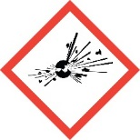 | 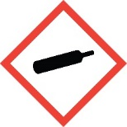 | 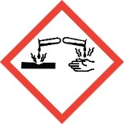 | 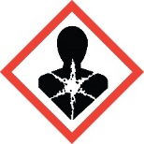 | 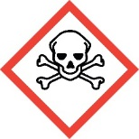 | 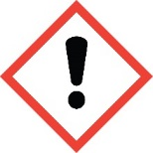 |  | 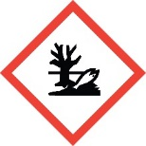
DANGER or WARNING [Choose proper signal word from the SDS]

[Insert Hazard Statements from the SDS]

Chemical composition | %

Name of Preparer: |  |  |  |  |  |  |  | Date:

