Hazardous Material Spill or Release
A hazardous material spill is an uncontrolled release of a substance that is potentially hazardous to humans, animals and/or the environment. University personnel and students working with hazardous materials, including chemicals, biological agents and radiological materials, should be prepared to respond in the event a spill or release occurs.
The University provides the following instructions to help UW personnel, students and visitors prepare for responding to an emergency on the Seattle campus. University units and departments can modify these instructions for their specific location(s) and add them to their Fire Safety and Evacuation Plans.

Emergency Spills or Releases
If you cause or witness a hazardous material spill that endangers people or may lead to a fire, follow these emergency procedures:
- Activate the fire alarm system. Pull the nearest fire alarm to evacuate the building.
- Call 9-1-1 as soon as you are safe. Report any details you know about the spill:
  - Location
  - Material and physical state (e.g., liquid, powder)
  - Quantity spilled
  - Any known hazardous characteristics
- Provide information such as the safety data sheet (SDS) or a chemical inventory to the fire department once they arrive. The fire department will stabilize the spill but might not clean it up.
Follow the instructions on the Spill Response Poster for biological, chemical and radiological releases (on page 2).
Follow the instructions on the Exposure Response Poster if an exposure to hazardous materials has occurred (on page 3).
- After the incident, schedule an exposure assessment through the UW Employee Health Center (206-685-1026) or your personal healthcare physician.
- Submit an incident report to the University’s Online Accident Reporting System (OARS) at oars.ehs.washington.edu.
- Contact the Environmental Health & Safety Spill Line at 206-543-0467 for assistance with contacting a spill cleanup contractor who will clean up and safely package the hazardous waste.

Non-emergency Spills
If the spill is contained and not endangering persons or property, it may be possible to clean it up yourself.
Call the EH&S spill line at 206-543-0467 for advice during business hours (Monday through Friday, 8 a.m. to 5 p.m.); after business hours, call the UW Police Department non-emergency phone number 206-685-UWPD.
Visit the Spills webpage on the Environmental Health & Safety website for more information.

Spill Response poster
The most recent version of the Spill Response Poster is available on the Environmental Health & Safety website.
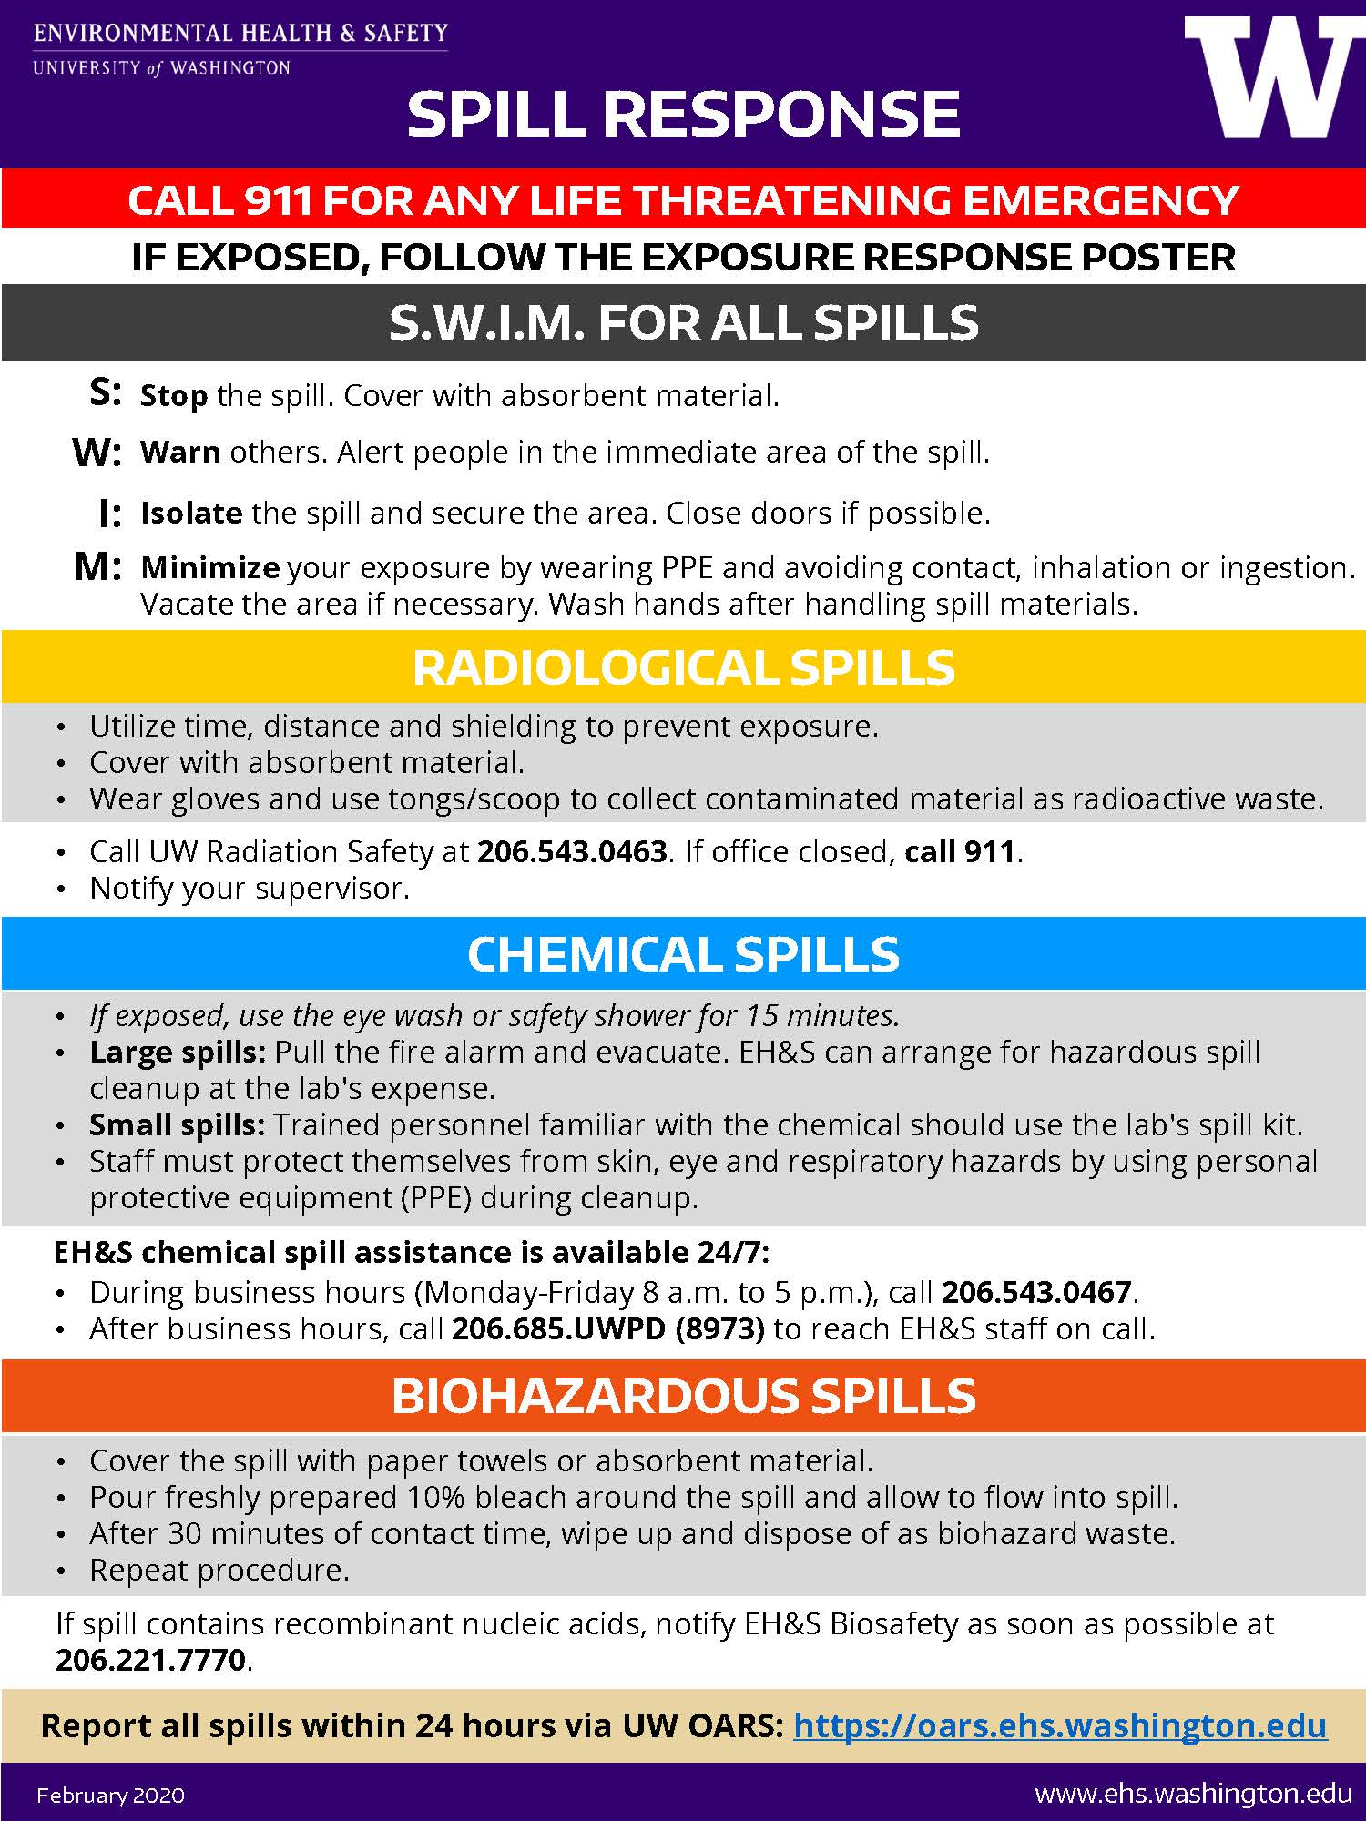

Exposure Response Poster
The most recent version of the Exposure Response Poster is available on the Environmental Health & Safety website.
