INSTRUCTIONS: This is an SOP template; it is complete when
1) All form fields have been completed to reflect chemical/lab-specific information, including adding relevant procedure information, or deleted inapplicable information; and
2) SOP has been signed and dated by the PI and relevant lab personnel.
Use safety data sheets (SDSs) as a resource for chemical-specific information. Text highlighted in gray indicates where information should be added or edited. Delete all instructions in red text and “Draft” watermark after the SOP is approved by PI.
Standard Operating Procedure
Methylene Chloride / Dichloromethane
Section 1 – Lab-Specific Information
Building/Room(s) covered by this SOP:
Unit or department:
Principal Investigator Name:
Principal Investigator Signature/Date:
This SOP was created by (if not PI):
Name/Title/Date/Signature

Section 2 – Hazards
Methylene chloride or dichloromethane (DCM) is a halogenated compound commonly used as an extraction solvent e.g., thin-layer chromatography application for isolating organic compounds. It is also commonly used in paint stripping applications. Methylene chloride/DCM is a regulated chemical in Washington State and is listed federally as a probable human carcinogen. This SOP documents the safe use of methylene chloride/DCM including the minimization of exposures via inhalation due to methylene chloride/DCM’s high volatility.
Acute effects: Very hazardous in case of skin/eye contact, ingestion, or inhalation. In case of ingestion, methylene chloride/DCM may cause irritation of the gastrointestinal tract with vomiting. If vomiting results in aspiration, chemical pneumonia could follow. Absorption through gastrointestinal tract may produce symptoms of central nervous system depression ranging from light-headedness to unconsciousness. Skin contact can result in irritation and redness, and DCM may be absorbed into the bloodstream). Prolonged contact may cause chemical burns and neuropathy. Inflammation of the eye is characterized by redness, watering, and itching. Eye contact may cause eye damage.
Chronic effects: Can cause headache, mental confusion, depression, liver effects, kidney effects, bronchitis, loss of appetite, nausea, lack of balance, and visual disturbances. Can cause dermatitis upon skin contact.
Mutagenic effects: Methylene chloride/DCM may cause cancer in humans.
Developmental toxicity: Methylene chloride/DCM is toxic to lungs, nervous system, liver, mucous membrane.
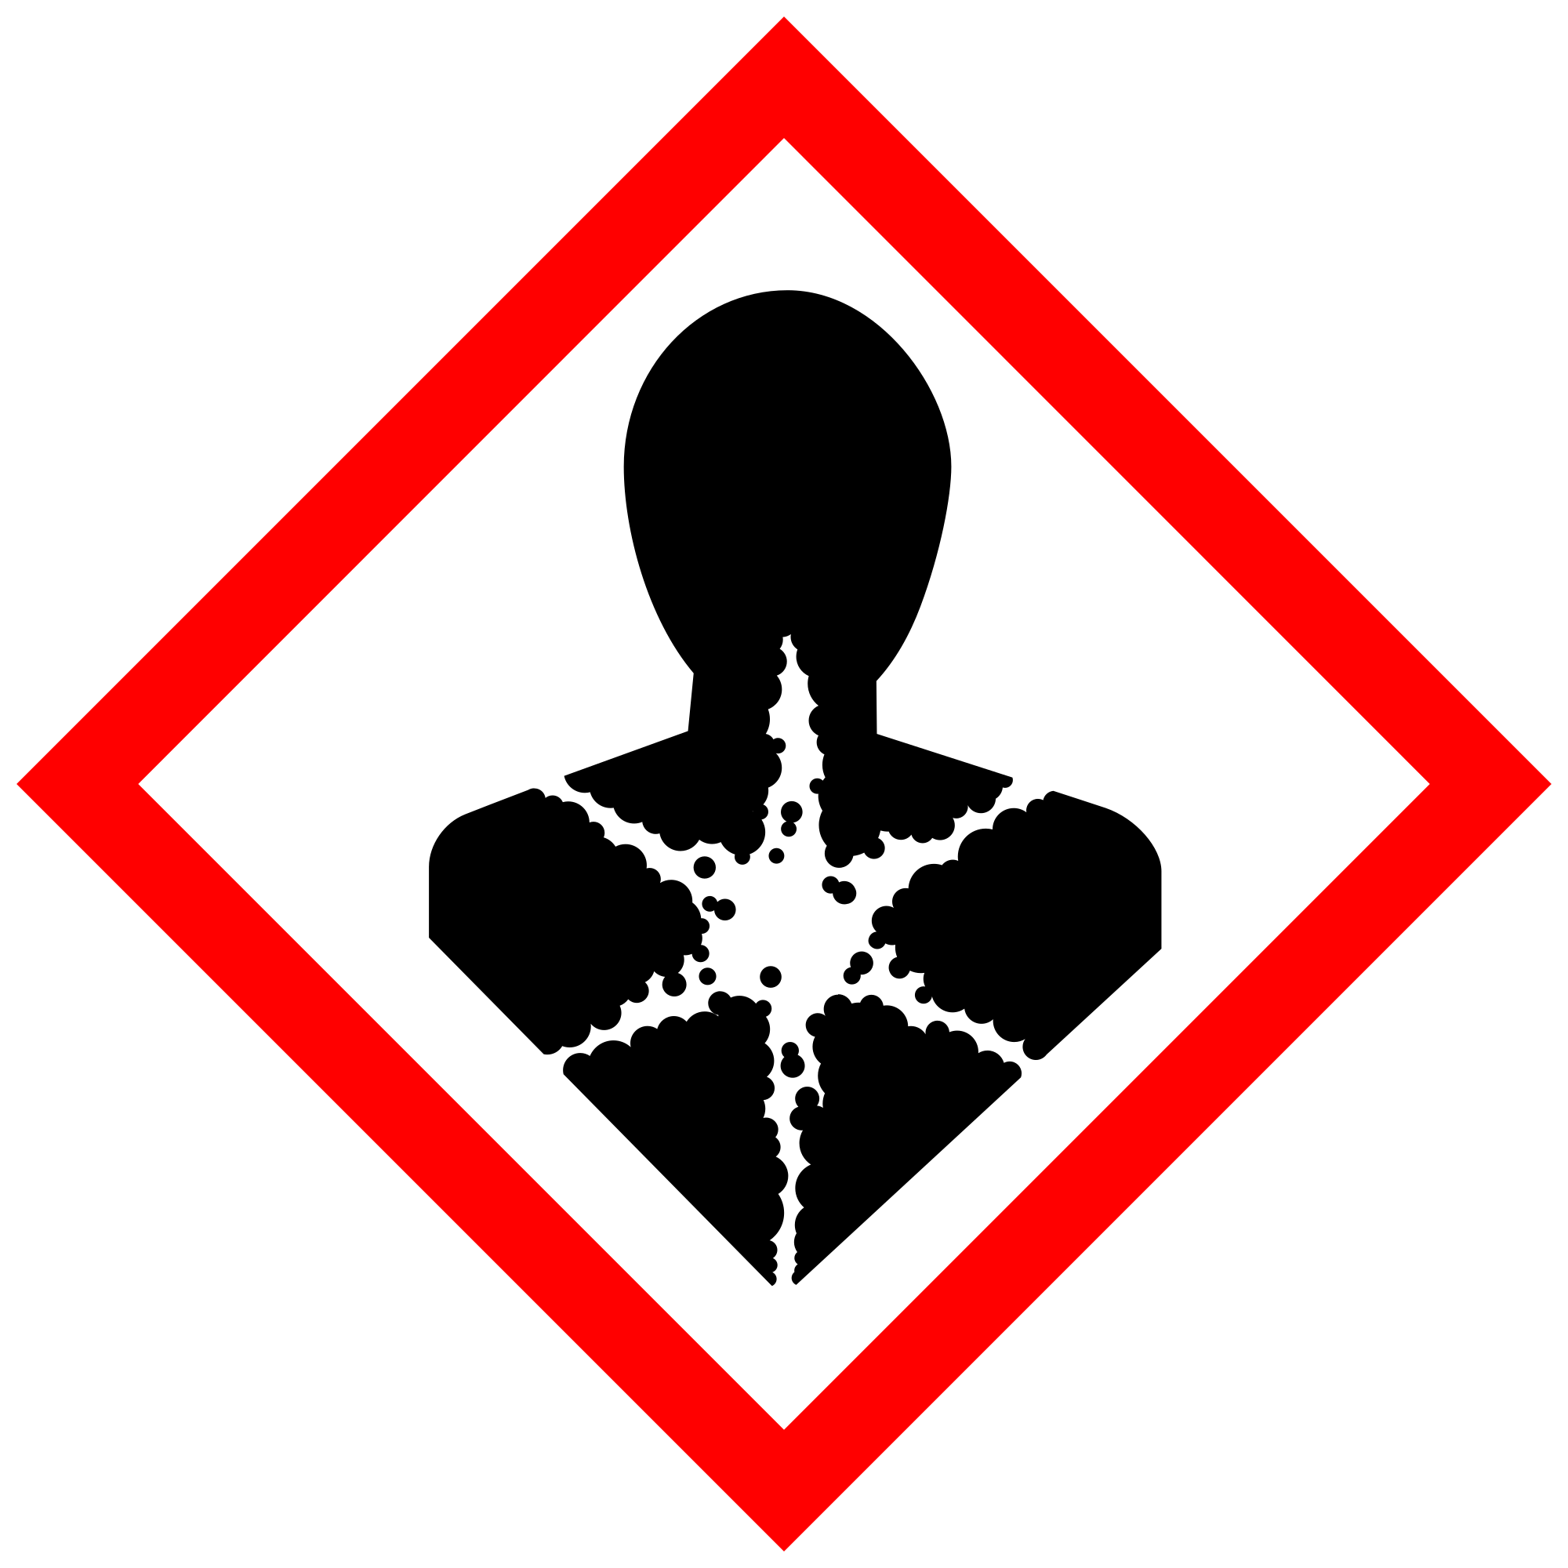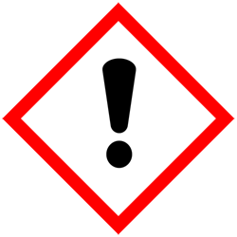
Section 3 – Engineering and Personal Protective Equipment (PPE)
Engineering Controls: Local exhaust ventilation is the best control to reduce vapors released during use of DCM. Wherever possible, the use of methylene chloride/DCM should be conducted in a properly functioning chemical fume hood which has been approved and tested by EH&S. Alternative solutions can include direct connected exhaust systems designed to capture the vapors at the point of release and/or closed-system operations designed to prevent the release of vapors.
Hygiene Measures: Avoid contact with skin, eyes, and clothing. Wash hands after removing PPE before breaks and immediately after handling the chemical.
Hand Protection: The most common gloves found in campus labs/storerooms (nitrile, neoprene and latex) are not recommended for use with methylene chloride due to the ease with which it permeates through the glove material. The recommended gloves are “Silver Shield”, polyvinyl alcohol, Viton, or “Barrier”. Gloves must be inspected prior to use. Use proper glove removal technique (without touching glove's outer surface) to avoid skin contact with this product. Dispose of contaminated gloves after use in accordance with applicable laws and good laboratory practices. Wash and dry hands.
Eye Protection: ANSI-approved safety glasses with side shields or tightly fitting safety goggles are required.
Skin and Body Protection: Laboratory coats must be worn and be appropriately sized for the individual and buttoned to their full length. Personnel must also wear full-length pants, or equivalent, and close-toed shoes. Full-length pants and close-toed shoes must be worn at all times by all individuals that are occupying the laboratory area. The area of skin between the shoe and ankle must not be exposed.
Respiratory Protection: Respirators should be used as a last line of defense (i.e., after engineering and administrative controls have been exhausted), and when any Action Limit (AL) or Occupational Exposure Limit (OEL) has been exceeded or when there is a possibility that an AL/OEL will be exceeded. If this activity is necessary, contact EH&S at 206.616.3777 so a respiratory protection analysis can be performed. Where air-purifying respirators are appropriate, use a full-face respirator with multi-purpose combination (US) or type AXBEK (EN 14387) respirator cartridges as a backup to engineering controls. Use a full-face supplied air respirator if it is the sole means of protection.
Section 4 – Special Handling and Storage Requirements
- Avoid contact with skin and eyes, and do not inhale.
- Do not store in aluminum containers. Methylene chloride/DCM reacts with aluminum and its alloys.
- Keep containers tightly closed. Store in a cool, dry, and well-ventilated area.
- Keep away from incompatible substances such as oxidizing agents, acids, and amines.
- Use in the smallest practical quantities for the experiment being performed.
- Work must be conducted in a properly functioning chemical fume hood.
- Do not store in a squirt bottle.
- Containers should remain closed when not in use.
- Containers should be labeled appropriately. Label should indicate the name of the chemical(s) in the container. Avoid using chemical abbreviations and formulae.
- Containers should be in good condition and compatible with the material.

Section 5 – Spill and Accident Procedures
Spills must be cleaned up immediately by properly protected and trained personnel who are not sensitive to methylene chloride/DCM. All other persons should leave the area. Spill response procedures must be developed based on the chemical and potential spill or release conditions. Clean up spills using contents of the spill kit. Do not attempt to clean up any spill if not trained or comfortable.
Exposures: If a person is injured, exposed, or suspected of being exposed to methylene chloride/DCM, follow procedures listed here. If skin is exposed to methylene chloride/DCM, remove contaminated clothing and shoes, rinse for 15 minutes in the safety shower. Send someone to call 911 as soon as possible. If eye is exposed, call 911 as soon as possible and flush eyes for 15 minutes in the eyewash. If methylene chloride/DCM is inhaled, remove to fresh air and call 911. Bring Safety Data Sheet (SDS) with you to show medical personnel.
Immediately evacuate area if fumes present a serious health risk or a large spill (> 250 mL) occurs outside the fume hood; ensure others are aware of the spill. Avoid breathing vapors. During normal business hours (Monday – Friday, 8 AM – 5 PM), call EH&S at 206.543.0467 for further assistance. If it is after hours, call 911 for further assistance. If possible, confine the spill to a small area using a spill kit or absorbent material. Keep others from entering contaminated area (e.g., use caution tape, barriers, etc.).
Spill procedures for spills inside a fume hood, BSC, glove box or approved containment and small spills (< 250 ml) outside of fume hood or containment:
- Spills, regardless of size, inside a fume hood can typically be cleaned up by trained people who are not sensitive to methylene chloride/DCM.
- Small spills outside a fume hood (< 250 ml) can also be managed by trained people who are not sensitive to methylene chloride/DCM.
- Personnel must wear a lab coat or smock, safety goggles, two pairs of disposable nitrile exam gloves or one pair of thicker nitrile or butyl gloves (minimum 10 mil thickness) or Silver Shield gloves and shoe covers as needed when cleaning up spills.
- Wipe up spilled liquids with absorbent pads. Cover the spill with the absorbent pads and allow to set for the prescribed contact time (usually 15 min.), and then scoop up and dispose of properly.
- Clean the spill area thoroughly with detergent solution followed by clean water.
- If spill is extensive within the containment, clean all interior surfaces after completion of the spill cleanup.
- Double bag all waste in plastic bags labeled with a hazardous waste label that reads "methylene chloride spill debris." Complete either an Online Chemical Waste Collection Request or a Chemical Collection Request Form found on the EH&S website. Email the form to chmwaste@uw.edu
Spill procedures for large spills (> 250 mL) outside of fume hood or containment:
- Large methylene chloride/DCM spills (> 250 ml) outside a fume hood or containment may generate vapors above methylene chloride/DCM exposure limits; therefore, these spills require the use of respiratory protection.
- Cover spill if possible to keep vapors down.
- Evacuate area and restrict access. Attend to injured or exposed persons using emergency shower or eyewash. Follow procedures listed above under Exposures.
- As soon as possible, report the spill in a safe area by notifying EH&S (during business hours (M-F/8-5) 206-543-0467, outside business hours 911* on a campus phone). Tell them that a spill has occurred, and you need help managing the spill. EH&S can arrange for a spill cleanup contractor. Notify supervisor.
- Be prepared to provide the following information:
- Name and phone number of knowledgeable person that can be contacted
- Name of chemical spilled, concentration and amount spilled, liquid or solid type spill
- Number of injured, if any
- Location of spill
This information can also be used in reporting to the Emergency Department (ED) after potential exposure.
- If staff are trained, have the proper PPE including respiratory protection, and are comfortable with cleaning up the spill, they may proceed to clean it up. Personnel must wear a lab coat or smock, safety goggles, two pairs of disposable nitrile exam gloves or one pair of thicker nitrile or butyl gloves (minimum 10 mil thickness) or Silver Shield gloves, shoe covers, and a respirator specifically for protection against methylene chloride/DCM. Respirator use requires enrollment in UW’s Respiratory Protection Program. Contact EH&S at uwresp@uw.edu for information or see https://www.ehs.washington.edu/workplace/respiratory-protection.
- Wipe up spilled liquids with absorbent pads. Cover the spill with the absorbent pads and allow to sit for the prescribed contact time (usually 15 min.), and then scoop up and dispose of properly.
- Clean the spill area thoroughly with detergent solution followed by clean water.
- Double bag all waste in plastic bags labeled with a hazardous waste label that reads "methylene chloride spill debris.” Complete either an Online Chemical Waste Collection Request or a Chemical Collection Request Form on the EH&S website. Email the form to chmwaste@uw.edu.
Report spills via the EH&S Online Accident Reporting System (OARS) within 24 hours (8 hours if serious injury or hospitalization).
Call EH&S at 206.543.0467 for further assistance during normal business hours (Monday – Friday, 8 AM – 5 PM). If it is after hours, call 911 for further assistance.
Section 6 – Waste Disposal Procedures
Double bag all waste in plastic bags labeled with a hazardous waste label that reads "methylene chloride spill debris.” Complete either an Online Chemical Waste Collection Request or a Chemical Collection Request Form on the EH&S website. Email the form to chmwaste@uw.edu Store hazardous waste in a designated area. Decontaminate equipment and bench tops using soap and water.

Section 7 – Protocol
Click here to enter text.
NOTE: Any deviation from this SOP requires approval from Principal Investigator.

Section 8 – Documentation of Training (signature of all users is required)
Prior to conducting any work with methylene chloride/DCM, the Principal Investigator must ensure that all laboratory personnel receive training on the content of this SOP.
I have read and understand the content of this SOP:
Name | Signature | Date

